**Day 17**

**Access Modifier Programs**

1. **Private Access Modifier within a class**

**package** abc;

**public** **class** A {

**private** **int** data=40;

**private** A()

{

System.***out***.println("Private Constructor");

}

**private** **void** msgPrivate()

{

System.***out***.println("Private Method called");

}

**public** **static** **void** main(String args[])

{

A ob = **new** A();

System.***out***.println("Private Data = "+ob.data);

ob.msgPrivate();

}

}

Output:

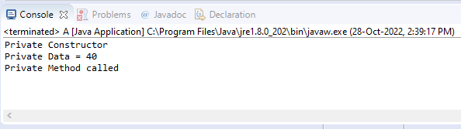

Note:

The private access modifier is accessible only within the class.

1. **Private Access Modifier within package**

**package** abc;

**public** **class** A {

**private** **int** data=40;

**private** A()

{

System.***out***.println("Private Constructor");

}

**private** **void** msgPrivate()

{

System.***out***.println("Private Method called");

}

**package** abc;

**public** **class** ABCMain {

**public** **static** **void** main(String args[])

{

A ob = **new** A();

System.***out***.println(ob.data);

ob.msgPrivate();

}

}

OUTPUT

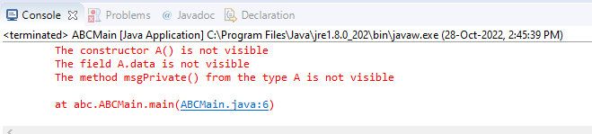

Note:

* The private access modifier is accessible only within the class. We are accessing these private members from outside the class, so there is a compile-time error.
* If you make any class constructor private, you cannot create the instance of that class from outside the class.

1. **Private access modifier Outside package by subclass only**

**package** abc;

**public** **class** A {

**private** **int** data=40;

**private** A()

{

System.***out***.println("Private Constructor");

}

**private** **void** msgPrivate()

{

System.***out***.println("Private Method called");

}

}

**package** def;

**import** abc.A;

**public** **class** E **extends** A {

**public** **static** **void** main(String args[])

{

E ob = **new** E();

ob.data;

ob.msgPrivate();

}

}

**OUTPUT:**

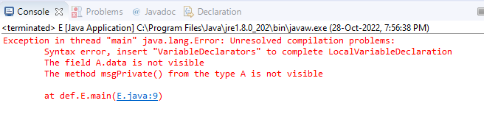

Note:

The private access modifier is accessible only within the class. We are accessing these private members from outside the package by subclass, so there is a compile-time error.

1. **Private access modifier outside package**

**package** abc;

**public** **class** A {

**private** **int** data=40;

**private** A()

{

System.***out***.println("Private Constructor");

}

**private** **void** msgPrivate()

{

System.***out***.println("Private Method called");

}

}

**package** def;

**import** abc.A;

**public** **class** D {

**public** **static** **void** main(String args[])

{

A ob = **new** A();

System.***out***.println(ob.data);

ob.msgPrivate();

}

}

**OUTPUT:**

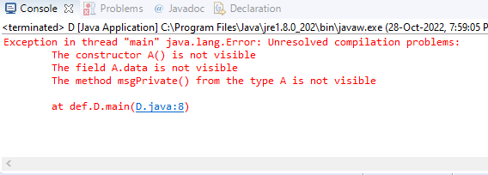

Note:

The private access modifier is accessible only within the class. We are accessing these private members from outside the package, so there is a compile-time error.

**-------------------------------------------------------------------------------------------------------------------------------------**

1. **Default Access modifier within a class**

**package** abc;

**public** **class** A {

**int** defaultData=20;

**void** defaultMsg()

{

System.***out***.println("Default Message");

}

**public** **static** **void** main(String args[])

{

A ob = **new** A();

System.***out***.println("Default Data = "+ob.defaultData);

ob.defaultMsg();

}

}

**OUTPUT:**

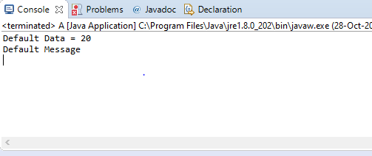

Note:

* If you don't use any modifier, it is treated as **default** by default.
* The default modifier is accessible within the class.

1. **Default Access modifier within a package**

**package** abc;

**public** **class** A {

**int** defaultData=20;

**void** defaultMsg()

{

System.***out***.println("Default Message");

}

}

**package** abc;

**public** **class** B **extends** A {

**public** **static** **void** main(String args[])

{

B ob = **new** B();

System.***out***.println("Default Data = "+ob.defaultData);

ob.defaultMsg();

}

}

**Output:**

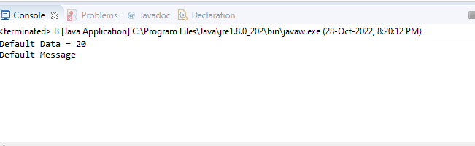

**Note:**

* The default modifier is accessible within a package.

1. **Default Access modifier outside package by subclass only**

**package** abc;

**public** **class** A {

**int** defaultData=20;

**void** defaultMsg()

{

System.***out***.println("Default Message");

}

}

**package** def;

**import** abc.A;

**public** **class** E **extends** A {

**public** **static** **void** main(String args[])

{

E ob = **new** E();

System.***out***.println(ob.defaultData);

ob.defaultMsg();

}

}

**OUTPUT**

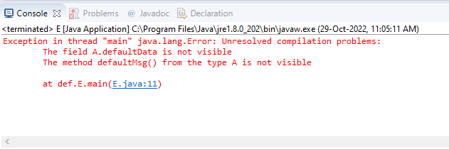

Note:

* Default access modifier is not accessible outside package by subclass.

1. **Default access modifier outside package**

**package** abc;

**public** **class** A {

**int** defaultData=20;

**void** defaultMsg()

{

System.***out***.println("Default Message");

}

}

**package** def;

**import** abc.A;

**public** **class** D {

**public** **static** **void** main(String args[])

{

A ob = **new** A();

System.***out***.println(ob.defaultData);

ob.defaultMsg();

}

}

**OUTPUT**

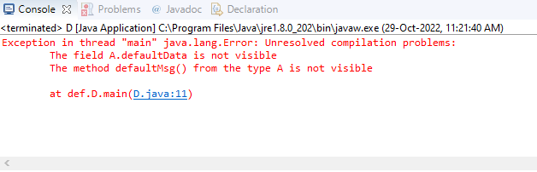

**NOTE:**

* Default access modifier is not accessible outside package.

1. **Protected Access modifier within a class**

**package** abc;

**public** **class** A {

**protected** **int** datapro = 10;

**protected** **void** msgProtected()

{

System.***out***.println("Protected Method called");

}

**public** **static** **void** main(String args[])

{

A ob = **new** A();

System.***out***.println("Protected Data = "+ob.datapro);

ob.msgProtected();

}

**OUTPUT:**

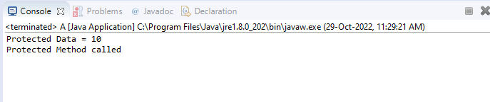

**Note:**

* The protected access modifier is accessible within the class.

1. **Protected access modifier within package**

**package** abc;

**public** **class** A {

**protected** **int** datapro = 10;

**protected** **void** msgProtected()

{

System.***out***.println("Protected Method called");

}

}

**package** abc;

**public** **class** B **extends** A {

**public** **static** **void** main(String args[])

{

B ob = **new** B();

System.***out***.println("Protected Data = "+ob.datapro);

ob.msgProtected();

}

}

**OUTPUT**

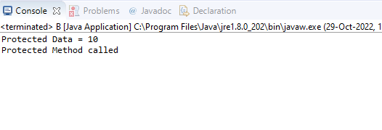

**Note:**

* The protected access modifier is accessible within the package.

1. **Protected Access modifier outside package by sub class only**

**package** abc;

**public** **class** A {

**protected** **int** datapro = 10;

**protected** **void** msgProtected()

{

System.***out***.println("Protected Method called");

}

}

**package** def;

**import** abc.A;

**public** **class** E **extends** A {

**public** **static** **void** main(String args[])

{

E ob = **new** E();

System.***out***.println(ob.datapro);

ob.msgProtected();

}

}

**OUTPUT:**

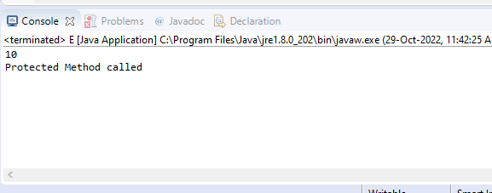

**Note:**

* The protected access modifier is accessible outside the package by sub class only.

1. **Protected Access modifier outside the package**

**package** abc;

**public** **class** A {

**protected** **int** datapro = 10;

**protected** **void** msgProtected()

{

System.***out***.println("Protected Method called");

}

}

**package** def;

**import** abc.A;

**public** **class** D {

**public** **static** **void** main(String args[])

{

A ob = **new** A();

System.***out***.println(ob.datapro);

ob.msgProtected();

}

}

**OUTPUT:**

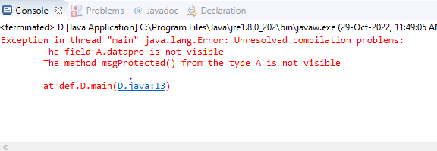

**Note:**

* The protected access modifier is accessible outside the package by sub class only.

1. **Public Access modifier within class**

**package** abc;

**public** **class** A {

**public** String name = "Jitty";

**public** **void** msgPublic()

{

System.***out***.println("Public Method called");

}

**public** **static** **void** main(String args[])

{

A ob = **new** A();

System.***out***.println("Public data, name = "+ob.name);

ob.msgPublic();

}

}

**OUTPUT:**

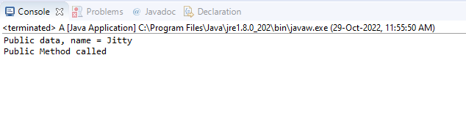

Note:

* Public access modifier is accessible within class

1. **Public access modifier within package**

**package** abc;

**public** **class** A {

**public** String name = "Jitty";

**public** **void** msgPublic()

{

System.***out***.println("Public Method called");

}

}

**package** abc;

**public** **class** B **extends** A {

**public** **static** **void** main(String args[])

{

B ob = **new** B();

System.***out***.println("Public Data = "+ob.name);

ob.msgPublic();

}

}

**OUTPUT**

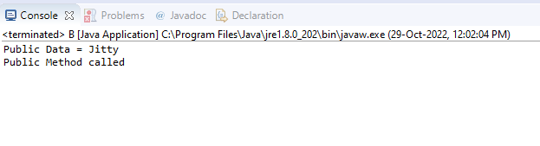

Note:

* Public access modifier is accessible within package.

1. **Public Access modifier outside package by subclass only**

**package** abc;

**public** **class** A {

**public** String name = "Jitty";

**public** **void** msgPublic()

{

System.***out***.println("Public Method called");

}

}

**package** def;

**import** abc.A;

**public** **class** E **extends** A {

**public** **static** **void** main(String args[])

{

E ob = **new** E();

System.***out***.println(ob.name);

ob.msgPublic();

}

}

**OUTPUT:**

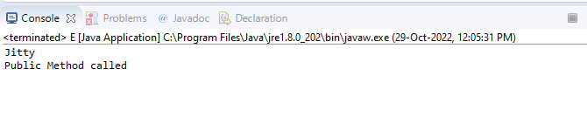

Note:

* Public access modifier is accessible outside package by subclass only.

1. **Public Access modifier outside package**

**package** abc;

**public** **class** A {

**public** String name = "Jitty";

**public** **void** msgPublic()

{

System.***out***.println("Public Method called");

}

}

**package** def;

**import** abc.A;

**public** **class** D {

**public** **static** **void** main(String args[])

{

A ob = **new** A();

System.***out***.println(ob.name);

ob.msgPublic();

}

}

**OUTPUT:**

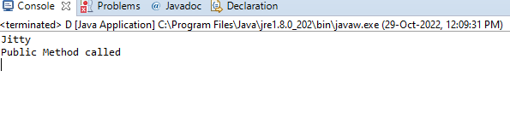

Note:

* Public access modifier is accessible outside package.